**A Farmer-Vendor Mobile Application, OnFarm.**

This is a guide through the screens of the application.

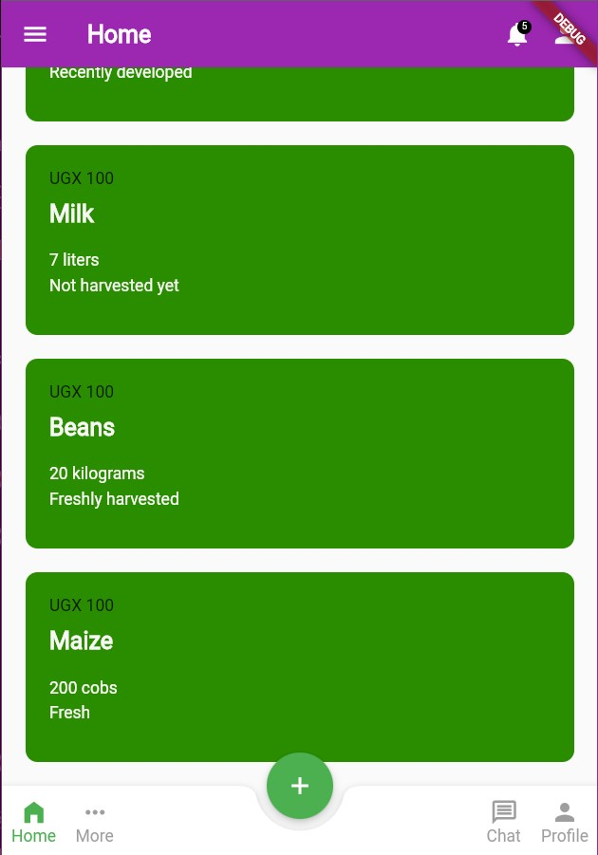

**Figure 1. The home page which shows all posts chronologically ordered.**

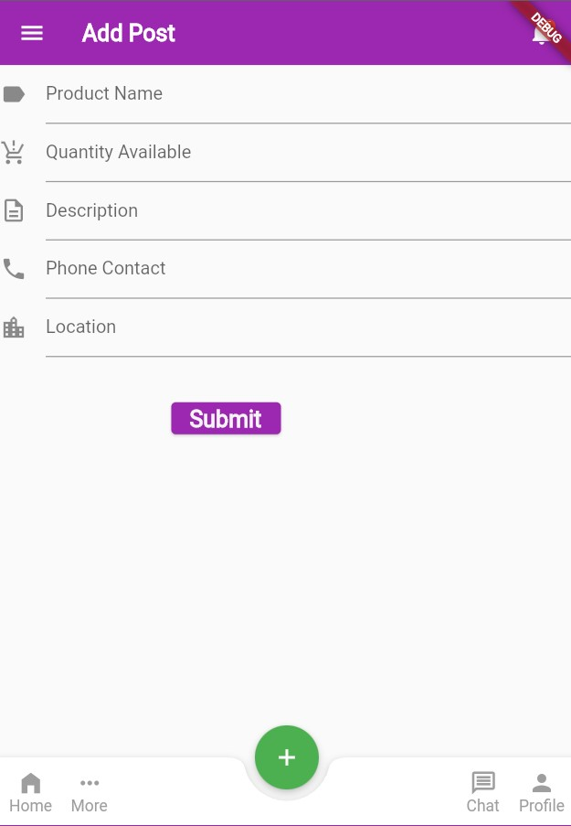

**Figure 2. The products page which shows a form that the user should fill out so as to add a new post.**

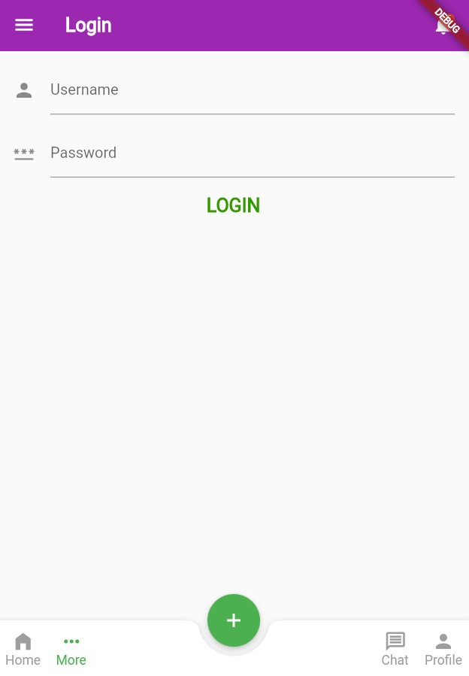

**Figure 3. Login page from which a user can login into the system.**

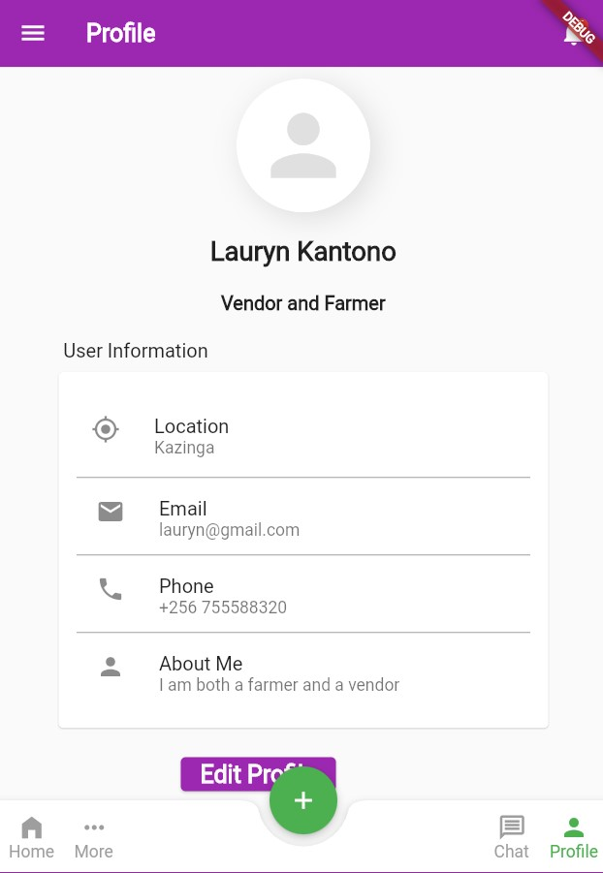

**Figure 4. Profile page which shows the user's personal details**

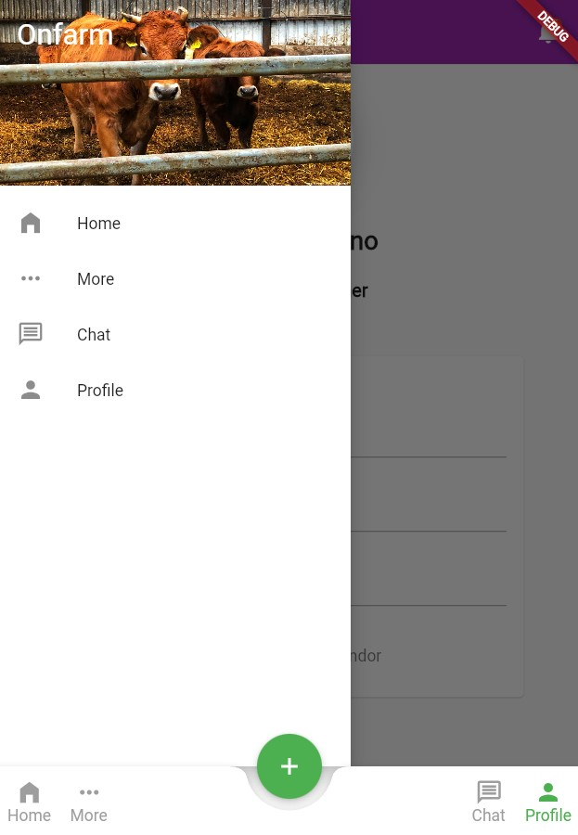

**Figure 5. Image showing the sidebar and bottom tab buttons for easy navigation from one screen to another.**